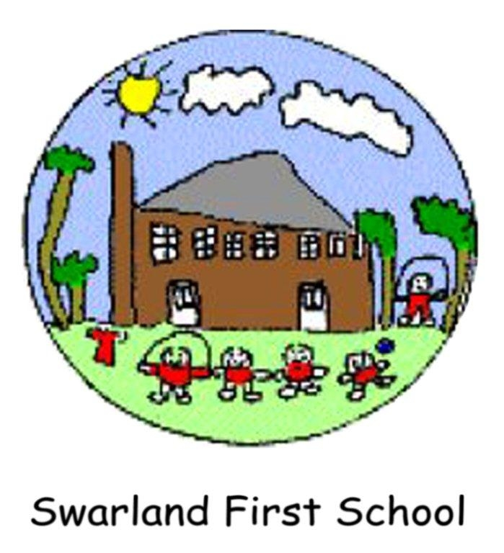

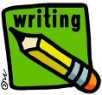

Our guide to how parents/carers can
support their children’s writing development throughout their time at Swarland First School from Foundation through to Key Stage 2.






From around the age of 2 years or even earlier, most children will show the skills of holding a large pencil or crayon and making marks on paper (and on lots of other places too !) Children usually try and draw pictures first and talk about these although they often won’t be recognisable!

As the child develops, their drawings become more recognisable and they may start to imitate writing.

My Mummy

Your child might also begin to talk about what they have drawn and what the writing says. Give them praise when they do this to encourage them to want to keep trying to write. It is important when your child begins to try and communicate with early writing that you take the time to read it with them. You will have to ask them what it says of course, but developing this link between written words and reading is important. As your child begins to understand that the squiggles they make on paper are like the print in books, the two activities of reading and writing begin to connect.
You can help your child to begin to make recognisable letters by writing their name on any pictures or early writing they produce. Always begin with a capital letter, but write the rest in lower case letters and only write their first name to start with.

A good way to start your child writing is to get them to draw a picture of a trip or exciting day they have recently had. Get your child to tell you something about the drawing and then write a simple sentence or phrase underneath. Your child will enjoy reading this back to you time and time again.

As writing requires fine motor control to hold a pen or crayon, you can improve your child’s skills by giving them other activities that require similar skills e.g. lacing cards and threading beads, construction sets, jig- saws, play-dough, big tweezers and opportunities to do up buttons! Make sure you provide them with plenty of materials to write both indoors and out. Pens, crayons, felt tips, chalks, paints, paper, card notebooks etc.

Once the children have gained confidence in mark making, they are also regularly introduced to more activities which help them develop their writing skills. These include; cutting, drawing and writing using whiteboards, tracing, writing names and letter formation using sand, foam and paint etc.

In school, during their time in the Foundation Stage, children are taught how to form letters correctly by practising their formation using tracing, drawing over lines etc. In the Foundation Stage it is our policy to teach lower case letters without trying to encourage children to join letters together in a cursive style.

As the children move into Key Stage 1, in Year 1, they will begin to learn how to join letters together by practising joined handwriting. This will help them to write faster as the quality and quantity of their writing improves. All this early handwriting practise will be done using a pencil. Once your child’s hand writing reaches a consistent and neat style they will be allowed to use a school handwriting pen.

Alongside practising their letter formation and handwriting children are taught phonics through the Read, Write, Inc programme. This is so they can develop the link between reading and writing further. The children are taught the sounds each letter of the alphabet can make and shown how these are blended together to form words. They will gradually begin to blend letter sounds and segment them to help them read and write.

Over time the children will gradually begin to move from recognising and writing basic consonant - vowel - consonant words (CVC) to constructing longer words and eventually simple phrases and then sentences. Children will also begin to develop sight vocabulary of high frequency words such as; the, and, who, went etc. which they will recognise without having to sound them out. Children will learn the sound a letter makes be- fore the name of the letter.

There is no set timescale to this as no two children are alike. However, the more stimulus and support you provide for your children before they start at school, the likelier it is they will begin to write with growing confidence from an earlier age.

It is very important that you show you value and appreciate your child’s early attempts at writing by giving them lots of praise. If a child is made to feel their early attempts at writing are no good, then they will very quickly become reluctant writers.

Between the ages of roughly 4 and 7 children begin to translate the words they hear and say into the letters that spell them. This is the beginning of what we call the ‘alphabetic principle’.

Usually the first word children learn to spell is their name because it is so important to their developing sense of self. Learning how to spell his or her name places your child on the road to learning many different things about print: they will learn about beginning sounds, that a name begins with a capital letter, followed by lowercase letters and most importantly, that there is a set order to the letters in their name that never changes.

The names of letters provide important clues for your child’s understanding of the sounds they make, but the letters and sounds in the English language invariably don’t correspond! As children try to figure out the relationship between letters and sounds, in their writing they will begin to invent their own way of spelling often using a letter naming strategy. This means that a child will write the letters they hear—such as l-f-n-t for elephant. They will often miss out vowels or hard to sound out consonants. When your child is trying to sound out words like this encourage them and help them to sound out the word slowly. This will help the child to segment words into phonemes or sounds. Hearing separate sounds in words and connecting them to letters is a vital beginning stage in your child’s ability to use phonics to decipher words. At Swarland First School daily work on phonics supports this stage of their development.
Over time through regular exposure to words through reading and seeing them around them, they will begin to build an understanding of how words should look. At this stage children’s minds will be combining and making sense of both what they hear and what they see. They will begin to realise that writing ‘hws’ for ‘house’ doesn’t look right even though they won’t yet understand all the rules for vowels and consonants!

At this stage your child may begin to develop a growing self- consciousness about not spelling things correctly. If they ask you, there will be an opportunity to explain how an adult spells the word, but try not to worry about giving complex explanations with spelling rules etc. as our language has lots of exceptions to these!

You can support your child’s journey to becoming a writer by pointing out some of the more mechanical aspects of writing such as capitalisation and punctuation, but in the beginning it is essential that written language is purposeful and meaningful to your child rather than grammatically correct.

Next are a few practical suggestions for activities that you can do with your child at home to help develop their enthusiasm, skills and enjoyment of writing.

Remember to ensure your child has fun in their learning or you may put them off writing rather than encourage them to become enthusiastic and willing writers.

Invite your child to keep a journal: Provide large sheets of unlined paper, which will accommodate developing hand-eye coordination skills. Most young children will ‘write’ with pictures, scribbles, random letters or the beginnings of phonic spellings. Encourage them to share their story by telling you about the pictures and encourage them to write it ‘their way’. You will hopefully find that stories about wonderful family experiences have an enduring interest and importance for your child.

Play Post Office at home: Create a simple post box by painting an old shoe box read and put a slit in the top. You can then write a letter to your child and encourage them to write back to you. You could put junk mail in the box, or coupons, which can be fun for pretend play. The game will really encourage your child to learn their name and that of others in the family.

Provide lots of writing materials: Find a place in your home where you can set up a small writing area—maybe the kitchen or lounge? Keep a pad of paper and writing materials handy for your child. Maybe expand the concept to a small chalkboard/white board where pictures or messages can be written. This could also be taken into role play situations like writing a shopping list.

Model writing: Begin each day by writing a message for your child -make it meaningful. They can respond to your message as they wish.

Developing Writing

As your child moves through from nursery into reception and then into
Key Stage 1 teachers will be providing a range of writing opportunities to build on their writing skills.

Children may be ability grouped to help ensure the learning is appropriate to their stage of development. Some children will receive extra support if either their reading or writing development is well below National Curriculum age expectations. This may be through working in a ‘Focus Group’ with a teacher or teaching assistant.

You can support your child’s writing progress by listening to them read regularly at home and by providing some of the writing opportunities listed earlier in this booklet.

In school, our writing development is supported by using materials from the Big Write Project. You may have seen the pyramids in classrooms when you have visited the school. These are based on four elements of writing; Punctuation, Connectives, Openers and Vocabulary. The pyramids are divided into levels which link to the National Curriculum, so children can see what sort of punctuation they need to incorporate into their writing to be working at a given level. These pyramids and other strategies to develop writing are used by staff throughout the school.

In the early parts of Key Stage 1 children are encouraged to write about things which interest them and which relate to their everyday lives. They use these experiences to draw upon when developing their ideas. As the children become more proficient writers they are challenged to write more creatively by retelling well known stories like The Three Billy Goats Gruff and other fairy tales. The children may make picture story boards to tell their story. Often the teachers will use drama to help fix the story in the children’s minds and to get them to think about how the characters behave and maybe the setting for the story.

Children might also be asked to express their ideas through writing poetry and simple plays. What is important at this stage is that they enjoy the experience of writing and they can see there is a purpose to it. All children’s writing, whatever their ability, is valued and maybe displayed in the classroom and around the school.

As children move into Key Stage 2 they will begin to look at different genres for writing and learn about the writing features of these genres. Children will look at examples of different genres from a variety of sources and after a teaching input of a few weeks be able to reproduce writing in a similar style. As they move through the Key Stage children will revisit these genres so they gradually become more confident and familiar with them. Over the next few pages are examples of the different genres the children will explore and some of the features children will become familiar with. We hope these examples may help you to support your child at home.

Find a special, calm place to work

Talk about the task and share ideas

Keep the work in a special writing folder

Ask your child;

What is the purpose of the writing? Is it going to be displayed?
Do they need to make a plan?
Do they think that spelling and handwriting matter?

HAVE LOTS OF FUN!!!!!

1. INSTRUCTIONS

Tells how to do or make something
♦ Do the activity together or act it out
♦ Jot down some memory joggers for each step
♦ Make a list of things you need
♦ Turn the memory joggers into sentences

Features of instruction writing;
♦ Simple, clear sentences
♦ Bossy verbs e.g. stick, paste, write, add, mix etc
♦ Number and time connectives e.g. next, now, later
♦ Important detail e.g. what, when, how, how much etc.
♦ Present tense

2. EXPLANATIONS

Tells you how or why something happens
♦ Say your sentence
♦ Write your sentence
♦ Read it again
♦ Can you improve it?

Features of explanation writing;
♦ Clear sentences
♦ Facts
♦ Present tense
♦ Introduction/conclusion
♦ Time connectives
♦ Technical vocabulary
♦ Sub headings

3. STORY WRITING

Tells you the story of someone or something
♦ Plan it in pictures or key words
♦ Remember to include a beginning, middle and ending
♦ Think about the setting and characters
♦ Think about punctuation
♦ Think about exciting words and description

Features of story writing;
♦ Beginning
♦ Middle
♦ Ending
4. REPORTS

Tells you facts and information about something
♦ Brainstorm what you know/need to find out
♦ Organise your information into groups
♦ Decide how to organise your information

Features of report writing;
♦ Impersonal language e.g. this group, they
♦ Present tense
♦ Technical vocabulary
♦ Clear sentences
♦ Introduction/conclusion
♦ Sub headings
♦ Facts

5. RECOUNTS

Tells you about something that has already happened
♦ It is written in time order
♦ It may be a newspaper report or a diary

Features of recount writing;
♦ Written in the 1st person
♦ Past tense
♦ Introduction/conclusion
♦ Time connectives e.g. next, then, first
♦ Description e.g. of events or feeling
♦ Chronological paragraphs
6. BIOGRAPHY

Factual writing about another person’s life, usually someone famous
♦ Find out all the facts about the person
♦ Place them in time order

Features of biography writing;
♦ Past tense
♦ Third person
♦ Facts e.g. when and where were they born? When did they die? Important dates in their lives etc.
♦ Opinions from other people
♦ Chronological order

7. AUTOBIOGRAPHY

A person writing about their own life
♦ Diary
♦ To tell us about your life

Features of autobiography writing;
♦ Past tense
♦ First person
♦ Dates and times
♦ Informal language
♦ Facts
♦ Opinions
♦ Description e.g. of events, what you saw,
your feelings etc.

8.DISCUSSION

This can also be called a debate or argument text and the text gives
points to argue for or against a point of view
♦ Details different views
♦ Backs these up with reasons
♦ Draws conclusions

Features of discussion writing;
♦ Impersonal language e.g. some people...
♦ Introduction often states facts
♦ Provides a balanced argument
♦ Persuasive language
♦ Formal language
♦ Supporting evidence
♦ Logical connectives e.g. however, therefore
♦ May contain statistics
♦ Conditional sentences
♦ Conclusion

9. PLAY SCRIPT
A story that people can act out
♦ Actors need to know what to say and how to act

Features of a play script;
♦ Present tense
♦ Stage directions
♦ Actors name on left side of page
♦ Indented speech
♦ Acts and scenes
10. LETTER WRITING

A piece of writing that can be formal or informal, usually from one
person to another
♦ Provides the reader with information
♦ Formal e.g. to a business or organisation
♦ Informal e.g. to a friend or relative

Features of letter writing
♦ Address of person sending the letter usually goes in the top right hand
corner of the page
♦ Date underneath the address
♦ Address the letter is going to is on left hand side of page if it is a for- mal letter
♦ Dear…… Sir/Madam or name of person/friend
♦ Paragraphs
♦ Signing off - Yours sincerely/faithfully or love etc.

We hope you have found the contents of this booklet helpful. It is not by any means a comprehensive list of all you can do to support your child’s writing development. However, we hope it gives a flavour of how children’s writing develops and some of the things you might do, in conjunction with school, to help ensure they progress well.
If you would like any further advice or guidance please do not hesitate to contact school. Thank you for taking the time to read this information.

